Instructions for Breath Hydrogen and Methane Small Intestinal Bacterial Overgrowth Test (SIBO)

Please read all the instructions carefully before you start the test and familiarise yourself with the test procedures. You must fully adhere to the pre-test dietary restrictions on page 2. The test results will only be valid if the samples are correctly collected.

- Verify the kit contents are complete (see below). If you are missing items, please contact us using the details in the header of this letter (take care when opening bag of glass tubes in case they have been damaged in transit)
- Never discontinue prescription medications without first consulting your doctor. If you are taking, or have recently taken, prescription antibiotics or natural antibacterial supplements then please discuss with your doctor / practitioner the optimal time to perform this test. We generally recommend that the test isn’t performed within 4 weeks of taking a course of antibiotics.
- You should not have had a colonoscopy or any full bowel cleansing preparation, including colonic lavage (‘cleansing’), for at least 1 week.
- Avoid the use of probiotics for at least 1 week before the test.
- Refrain from using motility enhancing drugs or laxatives for a week.
- Please note that the consumption of lactulose can soften your stool and may cause temporary bloating and abdominal discomfort.
- This test must not be performed on the same day as a lactose or fructose intolerance test breath test.

You will need:
- Bubble wrap packet for returning sample tubes
- Sample request form
- Instruction sheets
- Postal return items including cardboard
box, and pre-paid postal bag

- 15mL (10g) Lactulose sachet
(Prepare by mixing with 300mL water)
- Blue “EasySampler” mouthpiece and bag
- 10 x Glass collection tubes (do not remove caps)
- 10 x Sample tube labels
Sample Collection Instructions

- Please read and follow the pre-test “Dietary Advice” and “Sample Collection” instructions on pages 2 and 3. You should have fasted overnight before commencing this test.
- Collect your first breath sample into the first collection tube. Do not remove the cap from the glass tube at any point as this will invalidate the sample. Fill in and use the “Fasting” sample label.
- Mix the lactulose sachet contents with 300mL water and drink the solution. Please ensure that you use the full sachet, as not ingesting the entirety of the 10g lactulose provided may cause inaccurate results.
- Wait 20 minutes and collect your next breath sample.
- Complete the “20 Minutes” label and attach to the tube (as in image below).
- Repeat steps 4 – 5 every 20 minutes for 3 full hours, labelling each sample consecutively. Please note that once a tube has been used it cannot be reused.
- On completion of sample collection for all 10 tubes, place the tubes in the bubble wrap bag carefully.
- Place this into the cardboard box provided and place the box within the pre-paid postal bag.

Important Information:
If you are late collecting a sample, please collect the sample at the earliest opportunity and accurately record the later time that the sample was taken. Continue collecting the remaining samples at the original timescale.
(e.g., Fasting: 0 mins, Sample 1: 20 mins, Sample 2 (Delayed): 50 mins, Sample 3: 60 mins)
- Please attach the label with your information onto the correct tubes in the orientation as shown below:
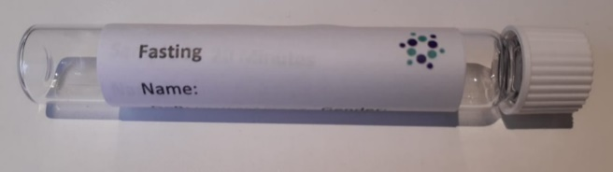

Dietary Advice for the Day Prior to your Hydrogen and Methane Breath Test

You should wait 4 weeks after completing a course of antibiotics or other antimicrobial treatment before undertaking breath hydrogen & methane tests. Avoid probiotics for 1 week before the test.
You must follow the dietary restrictions below on the day before the test.
You must fast for at least 12 hours before you start collecting your breath samples, this means you should not eat any food and only have water to drink. You should continue this fast during the test period and therefore most people prefer to commence the test early in the morning to limit the length of their fast.
Do not sleep or exercise vigorously for at least 1 hour before, or at any time during, the test. Do not smoke on the day of the test (including E-cigarettes and vaping).
On the day before the test do not eat high fibre or slowly digesting foods. Foods to avoid include:
- Bran, oats, and wheat-based cereals.
- Coarse breads (wholegrain, granary and soft grain varieties)
- Dairy products (i.e., milk, cheese, ice-cream, yoghurt, and butter)
- Beans and high fibre vegetables & their skins (i.e., potatoes, lentils, peas, carrots, broccoli, cabbage & celery)
- Fresh & dried fruits
- Wholegrain breakfast cereals, nuts and seeds
- Starches except for boiled white rice (i.e., DO NOT consume, potatoes, pasta, or brown rice)
- Herbs and spices
- Foods & drinks containing fructose
- Alcoholic beverages

Foods you may consume are:
Chicken, fish, turkey, beef, lamb, pork & ham, eggs, tofu, black/green tea (not herbal) & coffee (without milk), plain boiled white rice, tomato (not skins), breads (white, low fibre and gluten free), jelly and jam - (no artificial sweeteners).
If you are unsure, it’s best to avoid the food.
Pack and return your samples:
- Place the bubble-wrap bag containing all glass tubes into the white/brown cardboard return box.
- Place the provided sample request form into the white/brown cardboard return box.
- Seal the white/brown box.
- Place the white/ brown box into the grey postal bag with return label and seal.
IMPORTANT NOTE
We cannot process samples without all patient details included above, written on the sample container.
These MUST match the sample request form received with this sample.
It is highly recommended to post samples as soon as possible after collection between Monday - Thursday, to minimise delays in the laboratory receiving the sample over the weekend and ensure suitable sample stability.

If you have any questions, please do not hesitate to contact us using the details in the header of this letter.

Sample Collection Using the “EasySampler” Device
Do not insert your finger into the tube holder of the “EasySampler” at any time – it contains a sharp needle within the rubber housing.
Mouthpiece
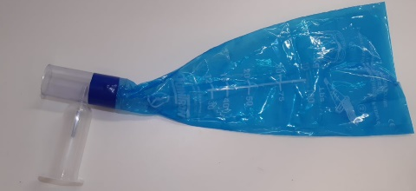
Before taking the test:
- Carefully remove the collection device from the sealed plastic bag.
- Ensure you have a mouthpiece with discard bag attached to the tube
holder/needle assembly and your 10 glass tubes to hand.
N/B: The blue discard bag has a vent hole in it to prevent overfilling.
Discard Bag
Tube Holder / Needle Assembly

Taking a sample:
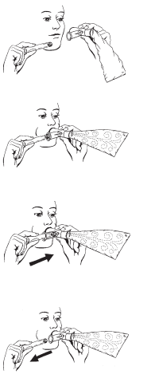
- Hold the “EasySampler” in one hand, and your fasting glass tube in the other
N/B: Do not loosen or remove the caps from these tubes as doing this will invalidate your sample.

- Partially insert the glass tube into the tube holder, cap first. Do not push the glass tube onto the needle yet.

- Taking a normal breath (not a deep breath), seal your mouth around the outside of the mouthpiece and exhale normally.

- As you exhale the discard bag will fill with air, and some will vent out through the vent hole.

- When the discard bag is inflated, continue to exhale and press the cap of the glass tube into the needle assembly to puncture the cap of the glass tube with the needle inside.

- Keep exhaling for 3 seconds with the needle inside the glass tube.

- Remove the glass tube from the needle assembly before you stop exhaling.

- Find the “Fasting” label sticker, and fill in your personal details, as well as sample collection time and date. Then stick the label to the tube in the orientation shown on page 2.

- Drink the lactulose solution after mixing with water, as described in page 2.

- Repeat this sample collection method every 20 minutes after drinking the solution as described in page 2, filling in each label, and attaching them to the glass tubes sequentially.

